|  |
| --- |
| BALL STATE UNIVERSITY – CS4MS |
| Activities, Worksheets and Additional Resources |
| Data, Abstraction and Hierarchy, Hardware and Software |
|  |
| **4/9/19** |
| [**http://www.cs.bsu.edu/cs4ms/**](https://nam05.safelinks.protection.outlook.com/?url=http%3A%2F%2Fwww.cs.bsu.edu%2Fcs4ms%2F&data=02%7C01%7Cajperry%40bsu.edu%7C9222a1aa9da145b551cc08d6bd19f0d6%7C6fff909f07dc40da9e30fd7549c0f494%7C0%7C0%7C636904317352320749&sdata=qa22i5tNJiZZgNXAVln9ADzl7HxRt%2B8v3arJ58YMwpM%3D&reserved=0)**docs/ResourcesCompilation.pdf** |

# 

# 

# 

# 

# 

# 

# 

# Worksheets

Name:________________________ Date:____________________  
Teacher:_______________________ Period:___________________

## Binary Worksheet

In this activity you will be converting base-10 numbers into base-2(binary) numbers. In 5-bit notation (the notation we are using) the first number=16, the second number=8, the third number=4, the fourth number=2, and the fifth number=1. For example, the 10110 would equal 16+0+4+2+0, therefore 10110=22. Each box represents a bit. The first 5 boxes are the 5-bit numbers on the left, the second 5 boxes are the 5-bit numbers on the right. I have given you the first number as an example.

Color the 0’s yellow and the 1’s black

|  |  |  |  |  |  |  |  |  |  |  |  |
| --- | --- | --- | --- | --- | --- | --- | --- | --- | --- | --- | --- |
| 7 | 0 | 0 | 1 | 1 | 1 |  |  |  |  |  | 28 |
| 8 |  |  |  |  |  |  |  |  |  |  | 2 |
| 26 |  |  |  |  |  |  |  |  |  |  | 11 |
| 22 |  |  |  |  |  |  |  |  |  |  | 13 |
| 16 |  |  |  |  |  |  |  |  |  |  | 1 |
| 20 |  |  |  |  |  |  |  |  |  |  | 5 |
| 18 |  |  |  |  |  |  |  |  |  |  | 9 |
| 25 |  |  |  |  |  |  |  |  |  |  | 19 |
| 12 |  |  |  |  |  |  |  |  |  |  | 6 |
| 7 |  |  |  |  |  |  |  |  |  |  | 28 |

The Picture above is a: ______________________________

Color the 0’s white and the 1’s red

|  |  |  |  |  |  |  |  |  |  |  |  |
| --- | --- | --- | --- | --- | --- | --- | --- | --- | --- | --- | --- |
| 5 |  |  |  |  |  |  |  |  |  |  | 28 |
| 13 |  |  |  |  |  |  |  |  |  |  | 30 |
| 29 |  |  |  |  |  |  |  |  |  |  | 31 |
| 29 |  |  |  |  |  |  |  |  |  |  | 15 |
| 28 |  |  |  |  |  |  |  |  |  |  | 23 |
| 29 |  |  |  |  |  |  |  |  |  |  | 27 |
| 29 |  |  |  |  |  |  |  |  |  |  | 27 |
| 28 |  |  |  |  |  |  |  |  |  |  | 23 |
| 15 |  |  |  |  |  |  |  |  |  |  | 14 |
| 7 |  |  |  |  |  |  |  |  |  |  | 28 |

The Picture above is a: ______________________________

Color the 0’s white and the 1’s black

|  |  |  |  |  |  |  |  |  |  |  |  |
| --- | --- | --- | --- | --- | --- | --- | --- | --- | --- | --- | --- |
| 16 |  |  |  |  |  |  |  |  |  |  | 1 |
| 18 |  |  |  |  |  |  |  |  |  |  | 9 |
| 18 |  |  |  |  |  |  |  |  |  |  | 9 |
| 18 |  |  |  |  |  |  |  |  |  |  | 9 |
| 9 |  |  |  |  |  |  |  |  |  |  | 18 |
| 7 |  |  |  |  |  |  |  |  |  |  | 28 |
| 11 |  |  |  |  |  |  |  |  |  |  | 26 |
| 19 |  |  |  |  |  |  |  |  |  |  | 25 |
| 21 |  |  |  |  |  |  |  |  |  |  | 21 |
| 21 |  |  |  |  |  |  |  |  |  |  | 21 |
| 20 |  |  |  |  |  |  |  |  |  |  | 5 |
| 16 |  |  |  |  |  |  |  |  |  |  | 1 |

The Picture above is a: ______________________________

### **Teacher Instructions**

Estimated Time: 25 min  
  
Purpose: Understand Binary

Instructions: Give some background on binary, we have a powerpoint to help  
  
Answers: Smiley Face, Beats Logo, Spider

Name:________________________ Date:____________________  
Teacher:_______________________ Period:___________________

## Evaluating Compound Conditionals

Determine if the following statements evaluate to **true** or **false**. Assume in every case that the two variables **age** and **day** have been initialized with the values shown.

**var age = 16;**

**var day = “Monday”;**

1. (day == "Mon") || (day == "Monday") (**true**) (**false**)

2. (day == "Tues") || (day == "Tuesday") (**true**) (**false**)

3. (day == "Tues") || (5 < 10) (**true**) (**false**)

4. (age > 10) && (age < 20) (**true**) (**false**)

5. !(age > 10) (**true**) (**false**)

6. (day == "Tuesday") || (age < 12) (**true**) (**false**)

7. !((age == 16) || (day == "Monday")) (**true**) (**false**)

8. !((age == 16) && !(day == "Monday")) (**true**) (**false**)

9. ((age == 16) && (day == "Monday")) && (day == "Tuesday") (**true**) (**false**)

10. ((age == 16) && (day == "Monday")) || (day == "Tuesday") (**true**) (**false**)

11. ((age > 10) && ((age + 5) > 20)) (**true**) (**false**)

### Teacher Instructions

**Estimated Time:** 30 - 45 minutes  
  
**Purpose:** To introduce some programming syntax and promote logical thinking.

**Instructions:** Teach the students/have a lesson about conditional statements. A conditional statement is a statement that only runs under certain conditions. Also, give the students an introduction about what each symbol represents: ==, &&, ||, !, etc. Do a few examples with the students before assigning the worksheet. We have a powerpoint to help explain this concept  
  
**Answers:**

1. True
2. False
3. True
4. True
5. False
6. False
7. False
8. True
9. False
10. True
11. True

# 

Name:________________________ Date:____________________  
Teacher:_______________________ Period:___________________

## Hamburger Activity Worksheet

1. In a couple short sentences, describe what parallelization is.

________________________________________________________________________________________________________________________________________________________________________________________________________________________________________________________________________________________________________________________________________________________________________________________________________________________________________________________________________________________________________________________________________________________________________________________________________________________________

1. Give an example of another real world task that would be difficult without “human” parallel processing.

____________________________________________________________________________________________________________________________________________________________________________________________________________________________________________________________________________________________________________________________________________________________________________________________________________________________________________________________________________________________________________________________________________________

1. Why did parallelization help when cooking a burger?

________________________________________________________________________________________________________________________________________________________________________________________________________________________________________________________________________________________________________________________________________________________________________________________________________________________________________________________________________________________________________________________________________________________________________________________________________________________________

1. Which of the following is a characteristic of parallelization?  
   A. Treats the entire task as one big problem  
   B. Completes each task one at a time  
   C. Breaks down tasks into smaller parts  
   D. Is really slow and complicated

______________________________________________________________________

### Teacher Instructions

Estimated Time: 20 min  
  
Purpose: To help the student think through what they just did  
  
Instructions:  
 Please do the Hamburger parallelization activity before completing the worksheet. Have students fill out the following worksheet after completing the activity, or similar activity over Parallelization. Please note that answer will vary, as long as a general understanding is shown, full credit should be given.

Example Answers:   
1. Parallelization is when multiple tasks can be done at the same time.

2. Working in any restaurant. Being a performer and playing a guitar while singing. Being a mom in a grocery store with kids who are hard to keep an eye on while trying to shop.  
  
3. Being able to work on many things at once, and not have to wait on every item to be finished significantly sped things up!  
  
4. C

Name:________________________ Date:____________________  
Teacher:_______________________ Period:___________________

## **How Technology has Changed Throughout History**

Match the following “old-technology” to the new technology by writing the letter that corresponds to the match.

|  |  |  |  |
| --- | --- | --- | --- |
| A |  |  |  |
| B |  |  | Image result for farming drones clipart |
| C |  |  | Image result for NEST |
| D |  |  | Image result for cool car |
| E |  |  | Image result for modern education |
| F |  |  | Image result for imax poster |
| G |  |  |  |

### Teacher Instructions

Estimated Time: 5 minutes  
  
Purpose: To understand the impact of technology

Instructions: Match the old technology to the new technology given the numbers provided.  
  
Answers: C, A, F, B, D, F, E

Name:________________________ Date:____________________  
Teacher:_______________________ Period:___________________

## **Logic circuits**

Even though computers can do everything from fly spaceships to play the latest Youtube videos, they are not very smart. Computers are only able to very simple operations millions or billions of times a second, which is fast enough to combine these many operations to do complex things.

The basic way in which computers look at data are called logical circuits. Logical circuits are a type of ***boolean expression***, meaning that they produce one of two values; such as true/false, yes/no, or 1/0. Each logical gate takes two boolean values as an input, and will produce a boolean value as an output which corresponds to the type of logical gate and the supplied input.

An **And Gate** outputs “True” only if both the A and B inputs are also “True”, else outputing “False.” This can be represented using the following table.

|  |  |  |  |
| --- | --- | --- | --- |
| Input | | Output |  |
| A | B |
| False | False | False |
| False | True | False |
| True | False | False |
| True | True | True |

An **OR Gate** outputs “True” if either of its inputs is true.

|  |  |  |  |
| --- | --- | --- | --- |
| Input | | Output |  |
| A | B |
| False | False | False |
| False | True | True |
| True | False | True |
| True | True | True |

Exclusive-Or Gate:

An **Exclusive-Or Gate** outputs “True” if either of its inputs is true, but not if both inputs are “True.”

|  |  |  |  |
| --- | --- | --- | --- |
| Input | | Output |  |
| A | B |
| False | False | False |
| False | True | True |
| True | False | True |
| True | True | False |

**Questions**:

Example:

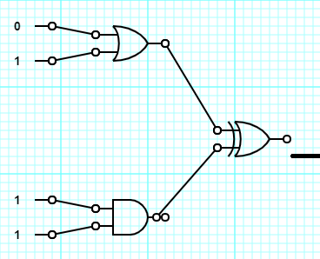

The above series of logic circuits outputs the value of 0. The **OR Gate** at the top outputs 1, and the **AND Gate** outputs 1. Using these values as the input to the **Exclusive-OR Gate** outputs 0.

#1)

Do the two logic circuits shown below output the same value? Use a full sentence to explain your answer.

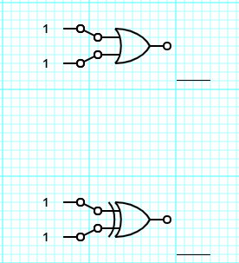

#2)

Write the output for this series of logical circuits.

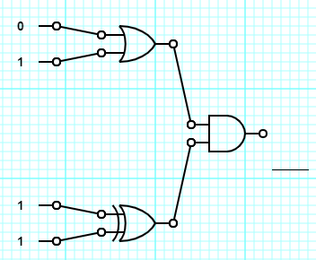

#3)

Write the output for this series of logical circuits. The new symbol switches the charge on the wire, true becomes false and vice versa. The circle placed in front of the other gate has the same function.

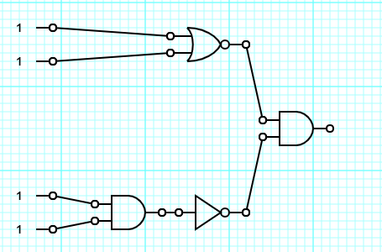

### Teacher Instructions

Estimated Time:  
  
Purpose: This worksheet will give students a basic overview of logic circuits, which are a portion of the 6-8.DI.4 standard.

Instructions:

The activity gives a basic explanation of how logic circuits work and the teacher should read over it to familiarize themselves. The following links also explain the concept of logic circuits in greater detail.

<http://www.ee.surrey.ac.uk/Projects/CAL/digital-logic/gatesfunc/>

<https://whatis.techtarget.com/definition/logic-gate-AND-OR-XOR-NOT-NAND-NOR-and-XNOR>

Answers:

#1) False

#2) The two logic circuits return a different value, because an OR Gate is true when both inputs are true while an Exclusive-OR Gate is false.

#3) False

Name:________________________ Date:____________________  
Teacher:_______________________ Period:___________________

## **Troubleshooting**

There are many times when our computers do not function as we want them to. When this happens, we can apply basic troubleshooting strategies. Troubleshooting is when try to fix a problem with your computer. Some tips for fixing your computer are:

* Apply basic troubleshooting strategies such as:
  + Always check cables
  + Restart the device
  + Watch for error messages
  + Use process of elimination to rule out problems
* Understand key shortcuts to important computer processes
  + Ctrl + Alt + Delete opens the Task Manager
  + Alt + f4 closes the current window
* Find trustworthy troubleshooting solutions with Internet searches

|  |  |
| --- | --- |
| **SLOW COMPUTER**  1. Close tabs/programs you don’t need.  2. Close internet and open again.  3. Restart the computer.  4. Remove large programs you don’t need. | **INTERNET WON’T WORK**  1. Click network/wireless icon in your  taskbar. Check you’re connected.  2. Check LAN settings (control panel  – internet options – connections).  3. Check LAN Cables are connected |
| **COMPUTER FREEZES**  1. If mouse won’t move, press  “Control-Alt-Delete”.  2. Click “Start task manager”.  3. Click “applications”, click on frozen  programs and click “end task”. | **PAGE WON’T LOAD**  1. Press F5 to refresh.  2. Close browser and open again.  3. Try a different browser (Firefox,  Chrome or Internet Explorer).  4. Check internet is connected. |

**Answer the question with what you would do first in the scenario:**

**Your computer screen is not displaying anything:**

**________________________________________________________________________________________________________________________________________________________________________________________________________________________________________________________________________________________________________________________________________________________________________________________________________________________________________________________________________**

**Your computer is not turning on:**

**________________________________________________________________________________________________________________________________________________________________________________________________________________________________________________________________________________________________________________________________________________________________________________________________________________________________________________________________________**

**Your webpage says, “No internet connection”:**

**________________________________________________________________________________________________________________________________________________________________________________________________________________________________________________________________________________________________________________________________________________________________________________________________________________________________________________________________________**

**Computer is freezing up or is too slow:**

**________________________________________________________________________________________________________________________________________________________________________________________________________________________________________________________________________________________________________________________________________________________________________________________________________________________________________________________________________**

Name:________________________ Date:____________________  
Teacher:_______________________ Period:___________________

## **Minimal Spanning Tree**

There is a city that had no roads. Getting around the city is very difficult after rainstorms because the ground became very muddy—cars got stuck in the mud and people got their clothes dirty. The mayor of the city decided that some of the streets must be paved, but wanted to spend the least amount of money possible. The mayor therefore specified two conditions:

1. Enough streets must be paved so that it is possible for everyone to travel from their house to anyone else’s house only along paved roads, and
2. The paving should cost as little as possible.

Here is the layout of the city. The number of paving stones between each house represents the cost of paving that route. Find the best route that connects all the houses, but uses as few counters (paving stones) as possible. 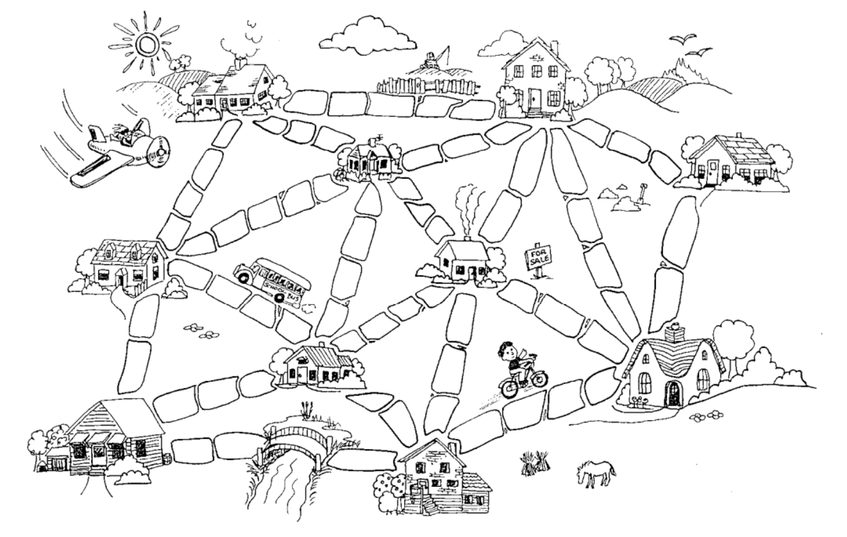

Assets and ideas used from

© 2005 Computer Science Unplugged (www.unplugged.canterbury.ac.nz)

### Teacher Instructions

Estimated Time: 20 minutes  
  
Purpose: Helping with the Algorithms standard  
  
Answers: These are the two best solutions

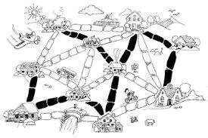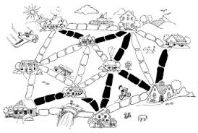

Name:________________________ Date:____________________  
Teacher:_______________________ Period:___________________

## Drawing Algorithm

**What is an algorithm?** A series of instructions to complete a task.

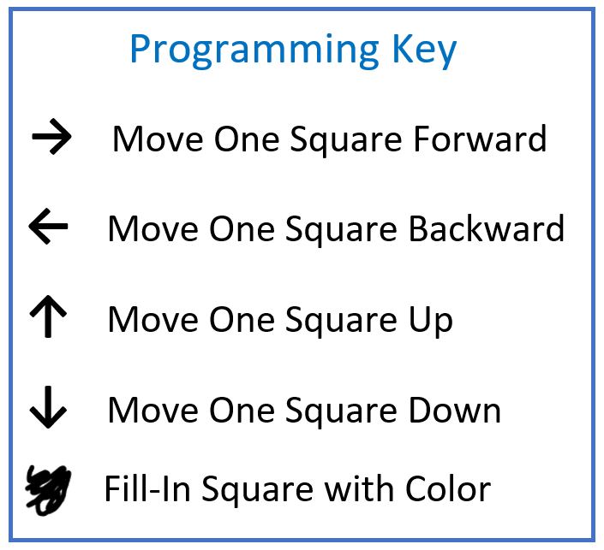

A full example is given below of an image to draw, the plain-English algorithm, and the algorithm in symbols. Note that the algorithm always starts in the upper leftmost corner.

**Your turn! Write The algorithm in symbols for the following drawing!**

|  |  |  |  |  |  |
| --- | --- | --- | --- | --- | --- |
|  |  |  |  |  |  |
|  |  |  |  |  |  |
|  |  |  |  |  |  |
|  |  |  |  |  |  |
|  |  |  |  |  |  |
|  |  |  |  |  |  |

|  |  |  |  |  |
| --- | --- | --- | --- | --- |
|  |  |  |  |  |
|  |  |  |  |  |
|  |  |  |  |  |
|  |  |  |  |  |
|  |  |  |  |  |

Now think about making the code a little shorter. For example, what could you replace “back, back” with?

Possibly **← 2**

You can use steps like these to make the algorithm shorter so it’s easier to read.

**Keep going!** Now write an algorithm in symbols to draw exactly the images below:

|  |  |  |  |  |  |
| --- | --- | --- | --- | --- | --- |
|  |  |  |  |  |  |
|  |  |  |  |  |  |
|  |  |  |  |  |  |
|  |  |  |  |  |  |
|  |  |  |  |  |  |
|  |  |  |  |  |  |

|  |  |  |  |  |  |  |
| --- | --- | --- | --- | --- | --- | --- |
|  |  |  |  |  |  |  |
|  |  |  |  |  |  |  |
|  |  |  |  |  |  |  |
|  |  |  |  |  |  |  |
|  |  |  |  |  |  |  |
|  |  |  |  |  |  |  |
|  |  |  |  |  |  |  |

# 

# 

# 

# 

# 

# 

# 

# Activities

## Hamburger Cooking Activity

**Teachers**: Parallel computing is when we have a process that needs to do multiple tasks at the same time. We can use the different cores of a processor to work on different tasks at the same time. Normally, instructions would be carried out in order, one at a time. Parallelization is the act of dividing the process up into tasks that can be accomplished at the same time, so that the computer does not need to wait for the previous task to be completed. This concept is to be explained after the activity to show that the idea of parallelization is not too intimidating, and to show how it can be helpful and save time.

The goal of this activity is to teach students the basics and show the benefits of parallelization. To accomplish this, we will place students in a real-world situation to show that we actually use parallelization in everyday life, and tell them that that is what a computer does to accomplish large tasks.

**Resources needed**:

* Two workstations for each group, one is the “prep station” and and the other is the “grill”
* Cutouts or other objects to represent the following items: Bottom bun, top bun, burger patty, lettuce, tomato, onions, and a plate.
* Timers. (Could even use a large clock in the room as long as it is visible.)

**Activity**: There are two types of groups, parallelization groups, and non-parallelization groups. Split the class into as many groups as needed, preferably 3-5 students each and randomly assign them to one of the two types of groups.   
Once the groups are formed, let the parallelization groups know that each member is their own “processor” that make up one computer, and that the non-parallelization groups represent a computer with just one processor.

Their goal is going to be to cook, prepare, and assemble a hamburger. The ingredients each have to be either cooked at the grill, or prepared at the prep station.   
Both Buns need to be **grilled** for 15 seconds, while the patty needs to be **grilled** for 60 seconds. The tomatoes, onions, and lettuce must be **prepared** at the prep station for 10 seconds each.  
Parallelization groups: Can cook and prepare multiple items at the same time, just need to make sure to assemble them on the plate in the proper order.

Non-Parallelization groups: Can only cook or prepare one thing at a time, once cooked or prepared, it must be added to the plate.

The burgers are constructed in the following order, Bottom Bun - Patty - Lettuce - Tomatoes - Onions - Top Bun.

Give each group 3-5 minutes to discuss the how they want to tackle the problem.

**Note**: The non-parallelization groups should quickly notice that they do not have a choice in the order for which they will have to do things, and the parallelization groups will try to figure out the fastest way to build the burger.  
After the teams are done discussing, it is time to cook! Have them cook and prepare their ingredients, and present you with their burgers when finished! The parallelization groups should be done a lot earlier than the non parallelization groups. Once teams are finished, repeat the activity, but switch the roll of each group so that every student gets to see the difference between parallelization and non-parallelization.

## How to Make a Peanut Butter and Jelly Sandwich Activity

**Purpose**: Not only does this activity help with practicing clear communication skills, it can show the difference between how humans and computers interpret instructions.

**Supplies**: Paper and writing utensils, peanut butter, Jelly, bread, plastic knife, paper towels, and a plate.

**Note**: Due to concerns about allergies, this activity can be completed with any task! It could even be opening a bag and getting out a notebook and pen to write down a message! Get creative!

**Set up**:

Split the class into several groups of around 3-6 students.   
Tell the class that you are going to try to make a peanut butter and jelly sandwich, but that they are going to have to write the instructions. Have each group take 5-10 minutes to to write out instructions step by step. Let the students know that you will be acting as a computer that only knows how to do what it is told. Students should be encouraged to be specific, but do not tell them how specific.   
  
Once all groups are are done, choose one group to give their instructions first. As the students read their instructions, act it out, and follow them as literal as possible. Example: If the instruction was “Grab a piece of bread” you should grab the bread, but from the outside of the bag, sine the instructions did not say to open the bag and to reach into it to get to the piece of bread. Or if the instructions were “Scoop the peanut butter onto the knife”, you could try to put the knife into the jar, but end up hitting the lid. “Spread the peanut butter onto the bread” could be done as spreading it on a piece of bread that is still in the bag.

After all the groups have tried their instructions, or at least as many as time will allow, explain to the group that you were demonstrating how computers need very specific instructions and only know what they are told, unlike humans who are able to interpret instructions even if steps are missing.

## How Computers Think Activities

**Objective**: Teach the basics of how we interact with computers and how they remember and process information.

**Materials**: For each student, a ruler and prints of the two worksheets (wave activity and grid activity). **This document contains the activities taken from the larger lesson plan and Powerpoint.** The complete lesson plan and additional resources are available from the following links:

* [**http://www.cs.bsu.edu/cs4ms/**](https://nam05.safelinks.protection.outlook.com/?url=http%3A%2F%2Fwww.cs.bsu.edu%2Fcs4ms%2F&data=02%7C01%7Cajperry%40bsu.edu%7C9222a1aa9da145b551cc08d6bd19f0d6%7C6fff909f07dc40da9e30fd7549c0f494%7C0%7C0%7C636904317352320749&sdata=qa22i5tNJiZZgNXAVln9ADzl7HxRt%2B8v3arJ58YMwpM%3D&reserved=0)**docs/HowComputersThinkLessonPlan.pdf**
* [**http://www.cs.bsu.edu/cs4ms/**](https://nam05.safelinks.protection.outlook.com/?url=http%3A%2F%2Fwww.cs.bsu.edu%2Fcs4ms%2F&data=02%7C01%7Cajperry%40bsu.edu%7C9222a1aa9da145b551cc08d6bd19f0d6%7C6fff909f07dc40da9e30fd7549c0f494%7C0%7C0%7C636904317352320749&sdata=qa22i5tNJiZZgNXAVln9ADzl7HxRt%2B8v3arJ58YMwpM%3D&reserved=0)**docs/HowComputersThinkSlides.pptx**
* [**http://www.cs.bsu.edu/cs4ms/**](https://nam05.safelinks.protection.outlook.com/?url=http%3A%2F%2Fwww.cs.bsu.edu%2Fcs4ms%2F&data=02%7C01%7Cajperry%40bsu.edu%7C9222a1aa9da145b551cc08d6bd19f0d6%7C6fff909f07dc40da9e30fd7549c0f494%7C0%7C0%7C636904317352320749&sdata=qa22i5tNJiZZgNXAVln9ADzl7HxRt%2B8v3arJ58YMwpM%3D&reserved=0)**docs/WaveActivity.pdf**
* [**http://www.cs.bsu.edu/cs4ms/**](https://nam05.safelinks.protection.outlook.com/?url=http%3A%2F%2Fwww.cs.bsu.edu%2Fcs4ms%2F&data=02%7C01%7Cajperry%40bsu.edu%7C9222a1aa9da145b551cc08d6bd19f0d6%7C6fff909f07dc40da9e30fd7549c0f494%7C0%7C0%7C636904317352320749&sdata=qa22i5tNJiZZgNXAVln9ADzl7HxRt%2B8v3arJ58YMwpM%3D&reserved=0)**docs/PixelGridActivity.pdf**

**Activies Lesson**:

* **Ruler Activity**
  1. Give each student a ruler. Have them try to line something up against a specific line of the ruler. Question them as to whether they’ve lined it up perfectly, with no error whatsoever between the position on the ruler and their item.
     + With **analog** data, such as the ruler, the item can be anywhere between the different lengths of the ruler. **Digital** data can only be represented exactly.
* **Wave Activity**
  1. Give each student a copy of the included worksheet.
  2. Instruct them on how to fill out the various spaces of the activity. Lead them through each section linearly, comparing their results to those displayed on the Powerpoint.
  3. After completing sections a through c, explain that the points they were connection represented different **resolutions** of **digital** data.
     + Each section took a different number of samples from the **analog** data provided. The larger the number of samples, the more closely the **digital** data resembled the **analog** data.
* **Pixel Grid Activity** (This activity requires a basic understanding of grid coordinates)
  1. Each student needs an activity sheet. The first page contains columns of grid coordinates. Begin filling out the coordinates on grid provided on the second page, completing the columns as ordered.
  2. When complete, the correct arrangement will spell out **C O M P U T E R S !**

## Analog vs. Digital Data Wave Activity

Name: ________________ Date: __________

Connect the dots in each of the following **digital** figures.

Each **digital** figure is a different **resolution** of the **analog data** (d).

The more points, the higher **resolution** the **digital data**.

(a) Digital Data – 3 Points (b) Digital Data – 5 Points

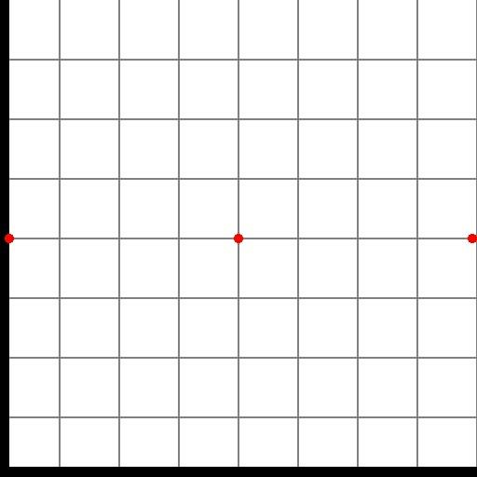 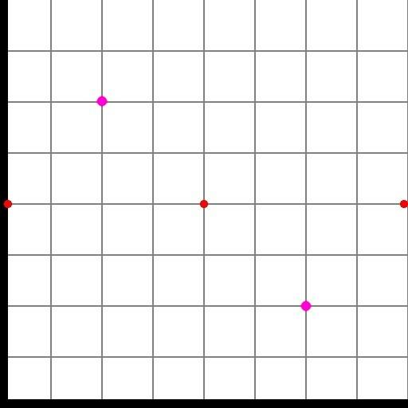

(c) Digital Data – 9 Points (d) Analog Data

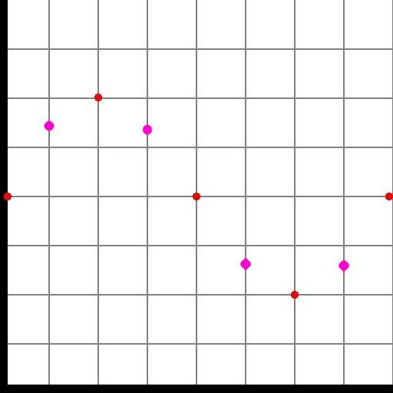 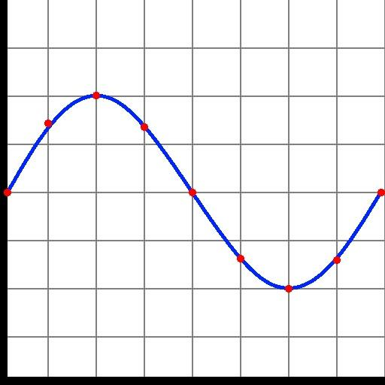

Notice how as the **resolution** of the **digital data** increases,

It starts to look more like the **analog data!**

**How Computers Store Images… Digitally (Pixel Grid Activity)**

Name: ________________ Date: __________

Fill in the space at each coordinate on the grid on the second page by using the provided grid below

